Разъемы питания для ноутбуков
PJ001
Диаметр центрального контакта 1.65, 2.0 и 2.5мм.
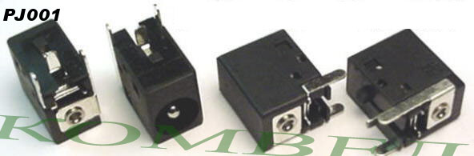
1.65mm
Acer Travelmate: 220, 230, 330, 332T, 370, 732, 734, 1350, 1360
Alienware: Area 51 Sentia
Compaq EVO: N110, N150, N180, N200, N400, N410, N600, N610, N620, N800, N800C, N800W, N800V
Compaq Armada: 100, 110, V300, E500, E500S, E700
Compaq Prosignia: 190SMB
Compaq Presario: 2800, 2800CA, 2800T, 2835CA
HP Pavilion ZE49xx series: ZE4900, ZE4901, ZE4902, ZE4903, ZE4904, ZE4905, ZE4906, ZE4907, ZE4908, ZE4909, ZE4910, ZE4911, ZE4912, ZE4915, ZE4918, ZE4920, ZE4922, ZE4923, ZE4925, ZE4926, ZE4927, ZE4928, ZE4929, ZE4930, ZE4935, ZE4940, ZE4945, ZE4950, ZE4955, ZE4960, ZE4965, ZE4970, ZE4974, ZE4975, ZE4980
2.0mm
Gateway: 600YGR/600YG2
Gateway Solo: 1200, 1400, 1450, 9500, 9550
2.5mm
Compaq Presario: 1000, 1010, 1020, 1030, 1060, 1065, 1070, 1072, 1075, 1080, 1090, 1090es, 1110
Compaq Presario:* 1200, 1207, 1210, 1215, 1220es, 1230, 1232es, 1234, 1235, 1236, 1237, 1238, 1240, 1242, 1244, 1245, 1246, 1247, 1250, 1252, 1255, 1256, 1260, 1266, 1267, 1270, 1272, 1273, 1274, 1275, 1277, 1278, 1279
Compaq Presario: 12XL, 1200XL119, 1200XL450, 12XL101, 12XL103, 12XL104, 12XL105, 12XL106, 12XL112, 12XL113, 12XL114, 12XL118, 12XL125
Compaq Presario:* 16XL, 1600, 1600s, 1600l, 1610, 1611, 1615, 1620, 1621, 1622, 1624, 1625, 1626, 1630, 1635, 1636, 1640, 1650, 1655, 1660, 1670, 1675, 1680, 1681, 1683, 1685, 1687, 1688, 1690, 1692, 1693, 1694
Compaq Presario:* 1800, 1805, 1810
Compaq Presario: 2100 Series, 2500 Series, most 2700 Series
Compaq Prosignia 150 SMB
Compaq Business Notebook NX9005, NX9008, NX9010
* Compaq is known to use several different types of DC Jacks for these models, personal verification should be done prior to purchase.
HP Omnibook XE series, XE2, 6000 Series XE4100, XE4500, 6000
HP Pavilion XZ series XZ133, XZ148, XZ163, XZ168, XZ275, XZ295, XZ335, ZX355
HP Pavilion XF series XF125, XF145, XF235, XF255, XF315, XF325, XF328, XF335
HP Pavilion XT series XT115, XT118, XT125, XT128, XT155, XT178, XT183, XT188, XT200, XT236, XT276, XT345, XT375, XT395, XT412, XT500, XT512, XT545, XT555, XT565, XT575, XT585, XT595, XT4345QV, XT4316WM, XT4328CL, XT4345QV, XT5335QV, XT5366WM, XT5377QV, XT5477WM
HP Pavilion N series N3000, N3100, N3110, N3150, N3190, N3200, N3210, N3215, N3250, N3270, N3290, N3295, N3300, N3310, N3330, N3350, N3370, N3390, N3400, N3402, N3410, N3438, N3478, N3490
HP Pavilion ZT series ZT1172, ZT1182
HP Pavilion ZE series ZE1000, ZE1100, ZE1115, ZE1145, ZE1200, ZE1201, ZE1202, ZE1210, ZE1230, ZE1235, ZE1250, ZE1260 ZE4000, ZE4200, ZE4100, ZE4935, ZE4400, ZE4100, ZE4101, ZE4102, ZE4103S, ZE4105S, ZE4111S, ZE4115, ZE4120S, ZE4123, ZE4123S, ZE4125, ZE4130, ZE4133, ZE4140, ZE4145, ZE4200, ZE4201, ZE4204, ZE4207, ZE4208, ZE4209, ZE4210, ZE4211, ZE4212, ZE4214, ZE4218, ZE4219, ZE4220, ZE4221, ZE4222, ZE4222AP, ZE4224, ZE4228, ZE4229, ZE4230, ZE4231, ZE4232, ZE4234, ZE4236, ZE4239, ZE4240, ZE4241, ZE4251, ZE4257EA, ZE4258, ZE4261, ZE4262, ZE4268, ZE4271, ZE4274, ZE4278, ZE4281, ZE4282, ZE4284, ZE4288, ZE4292, ZE4294, ZE4298, ZE4300, ZE4301, ZE4302, ZE4305EA, ZE4306WM, ZE4307LA, ZE4308EA, ZE4310, ZE4310EA, ZE4311, ZE4312, ZE4313, ZE4314, ZE4315, ZE4315CA, ZE4315US, ZE4316, ZE4317, ZE4317EA, ZE4318, ZE4318EA, ZE4319, ZE4320EA, ZE4321, ZE4321EA, ZE4322EA, ZE4323EA, ZE4325CA, ZE4325EA, ZE4325US, ZE4326, ZE4328US, ZE4332EA, ZE4333EA, ZE4334EA, ZE4335EA, ZE4335US, ZE4336EA, ZE4345EA, ZE4345US, ZE4347EA, ZE4348EA, ZE4349EA, ZE4351EA, ZE4352EA, ZE4353EA, ZE4354EA, ZE4355EA, ZE4355US, ZE4356EA, ZE4357EA, ZE4358US, ZE4360EA, ZE4365US, ZE4367EA, ZE4375EA, ZE4384EA, ZE4385EA, ZE4386EA, ZE4400, ZE4400, ZE4401US, ZE4402US, ZE4403EA, ZE4404EA, ZE4405EA, ZE4407EA, ZE4408EA, ZE4409EA, ZE4410AK, ZE4410AP, ZE4410CA, ZE4410EA, ZE4411AP, ZE4412AP, ZE4413AP, ZE4414AP, ZE4414EA, ZE4415AP, ZE4415EA, ZE4416AP, ZE4416EA, ZE4417EA, ZE4420CA, ZE4420US, ZE4423EA, ZE4424EA, ZE4424US, ZE4425EA, ZE4427WM, ZE4428EA, ZE4430US, ZE4453EA, ZE4454EA, ZE4455EA, ZE4500, ZE4500, ZE4501US, ZE4502US, ZE4504EA, ZE4505EA, ZE4507EA, ZE4508EA, ZE4509EA, ZE4510AP, ZE4510EA, ZE4510OM, ZE4511EA, ZE4512EA, ZE4513EA, ZE4514EA, ZE4516EA, ZE4518EA, ZE4519EA, ZE4520AP, ZE4520EA, ZE4521AP, ZE4521EA, ZE4522AP, ZE4522EA, ZE4523AP, ZE4523EA, ZE4524EA, ZE4525EA, ZE4525US, ZE4526EA, ZE4530US, ZE4540CA, ZE4540US, ZE4545US, ZE4546SR, ZE4547WM, ZE4550ST, ZE4560US, ZE4565QV, ZE4600, ZE4600, ZE4601US, ZE4603EA, ZE4604EA, ZE4605EA, ZE4610EA, ZE4610US, ZE4612EA, ZE4614EA, ZE4615EA, ZE4630US, ZE4710EA, ZE4715EA, ZE4717EA, ZE4718EA, ZE4719EA, ZE4725EA, ZE4728EA, ZE4800 CTO, ZE4801EA, ZE4803US, ZE4805US, ZE4805WM, ZE4810US, ZE4815EA, ZE4819EA, ZE4820EA, ZE4821EA, ZE4828EA, ZE5000, ZE5100, ZE5155, ZE5160, ZE5165, ZE5170, ZE5185, ZE5190, ZE5200, ZE5207, ZE5217, ZE5228, ZE5232, ZE5236, ZE5238, ZE5240, ZE5242, ZE5244, ZE5250, ZE5252, ZE5258, ZE5262, ZE5270, ZE5279, ZE5300, ZE5307LA, ZE5315EA, ZE5320AP, ZE5320EA, ZE5325EA, ZE5339EA, ZE5343EA, ZE5344EA, ZE5345EA, ZE5345US, ZE5354EA, ZE5357LA, ZE5360EA, ZE5362EA, ZE5365US, ZE5375US, ZE5385CA, ZE5385US, ZE5395US, ZE5400, ZE5407LA, ZE5410AP, ZE5413EA, ZE5414EA, ZE5415AP, ZE5415EA, ZE5416EA, ZE5417LA, ZE5418EA, ZE5420EA, ZE5425EA, ZE5426EA, ZE5427LA, ZE5430EA, ZE5440EA, ZE5443EA, ZE5445EA, ZE5446EA, ZE5447LA, ZE5451US, ZE5457LA, ZE5460EA, ZE5460US, ZE5462EA, ZE5467LA, ZE5468CL, ZE5470US, ZE5475CA, ZE5477LA, ZE5477WM, ZE5478CL, ZE5490US, ZE5497LA, ZE5500, ZE5501US, ZE5504EA, ZE5505EA, ZE5506EA, ZE5507EA, ZE5510AP, ZE5510EA, ZE5511AP, ZE5511EA, ZE5512AP, ZE5512EA, ZE5513AP, ZE5514AP, ZE5515AP, ZE5515EA, ZE5516AP, ZE5516EA, ZE5517AP, ZE5517EA, ZE5518AP, ZE5519AP, ZE5519EA, ZE5520EA, ZE5521AP, ZE5521EA, ZE5522AP, ZE5523AP, ZE5523EA, ZE5524AP, ZE5524EA, ZE5525AP, ZE5525EA, ZE5526AP, ZE5526EA, ZE5527EA, ZE5528EA, ZE5529EA, ZE5530EA, ZE5531EA, ZE5532EA, ZE5533EA, ZE5534EA, ZE5535EA, ZE5537LA, ZE5547WM, ZE5560US, ZE5565QV, ZE5568CL, ZE5570US, ZE5575SR, ZE5580US, ZE5587LA, ZE5590US, ZE5600, ZE5601AP, ZE5601EA, ZE5602AP, ZE5602EA, ZE5602US, ZE5603AP, ZE5603EA, ZE5604AP, ZE5604EA, ZE5604RS, ZE5605AP, ZE5605EA, ZE5605SR, ZE5607EA, ZE5607WM, ZE5608AP, ZE5609AP, ZE5609EA, ZE5610AP, ZE5610CA, ZE5610EA, ZE5611AP, ZE5611EA, ZE5612AP, ZE5612EA, ZE5613AP, ZE5613EA, ZE5614AP, ZE5614EA, ZE5615AP, ZE5615CA, ZE5615EA, ZE5615SR, ZE5616AP, ZE5616EA, ZE5617AP, ZE5617EA, ZE5617WM, ZE5618EA, ZE5619EA, ZE5620EA, ZE5620US, ZE5622EA, ZE5623EA, ZE5624EA, ZE5626EA, ZE5630US, ZE5631EA, ZE5635EA, ZE5636EA, ZE5637LA, ZE5638EA, ZE5640EA, ZE5645EA, ZE5647LA, ZE5701US, ZE5731US, ZE5738RS, ZE5739CL, ZE7185
Acer Aspire: 1300, 1301XV, 1302, 1304, 1315LT
ECS: G550, G551, G710, G730, G731, G732, G736
IBM I series: 1400 Series, 1500 Series
Packard Bell Easynote: 7321, 7521
Fujitsu Siemens C Series LifeBook: C1020, C2111

PJ002
Диаметр центрального контакта 2.0 и 2.5мм.
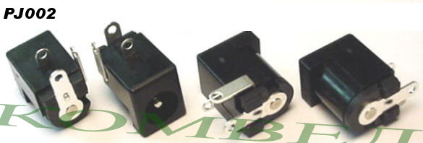
2.0mm
Gateway Solo: 2200, 2250, 2300, 2500, 2550, 5100
2.5mm
Compaq Presario 700US, 700xx, 700Z, 705US, 709EA, 710CA, 710TC, 710US, 711AU, 711CL, 711EA, 711LA, 712EA, 712LA, 713EA, 715CA, 715EA, 717RSH, 720AU, 720CA, 720JP, 720LA, 720TC, 721CL, 722EA, 722US, 723EA, 723RSH, 725AU, 725CA, 725EA, 725LA, 725US, 726EA, 730AP, 730US, 735CA
Compaq Presario* 1200SC, 1200T, 1200TH, 1200xx, 1200Z, 1201T, 1210, 1210US, 1211, 1212, 1214, 1215US, 1219JP
Compaq Presario 12XL, 12XL201, 12XL202, 12XL203, 12XL204, 12XL205, 12XL206, 12XL211, 12XL212, 12XL212, 12XL220, 12XL222, 12XL223, 12XL3, 12XL300, 12XL300A, 12XL300B, 12XL301, 12XL302, 12XL303, 12XL304, 12XL305, 12XL307, 12XL310, 12XL311, 12XL312, 12XL314, 12XL320, 12XL323, 12XL325, 12XL326, 12XL327, 12XL330, 12XL402, 12XL403, 12XL411, 12XL412, 12XL414, 12XL416, 12XL421, 12XL426, 12XL427, 12XL428, 12XL430, 12XL500, 12XL501, 12XL502, 12XL504, 12XL505, 12XL509, 12XL510, 12XL512, 12XL513, 12XL515, 12XL517, 12XL519, 12XL520, 12XL521, 12XL526, 12XL527, 12XL530, 12XL531
Compaq Presario 14XL, 14XL240, 14XL241, 14XL242, 14XL340, 14XL341, 14XL342, 14XL343, 14XL344, 14XL345, 14XL346, 14XL350, 14XL352, 14XL355, 14XL356, 14XL420, 14XL440, 14XL442, 14XL443, 14XL444, 14XL445, 14XL446, 14XL452, 14XL453, 14XL455
Compaq Presario* 1600, 1600T, 1650, 1655, 1600XL, 1600XL1, 16XL, 16XL140, 16XL141, 16XL142, 16XL143, 16XL144, 16XL145, 16XL146, 16XL147, 16XL150, 16XL255, 16XL256, 16XL257, 16XL258
Compaq Presario* 1700, 1700T, 1701S, 1702TC, 1710T, 1720CA, 1720US, 1722US
Compaq Presario 17XL, 17XL260, 17XL261, 17XL262, 17XL264, 17XL265, 17XL266, 17XL274, 17XL275, 17XL360, 17XL361, 17XL362, 17XL364, 17XL365, 17XL366, 17XL367, 17XL368, 17XL369, 17XL370, 17XL371, 17XL372, 17XL374, 17XL375, 17XL376, 17XL378, 17XL379, 17XL380, 17XL460, 17XL461, 17XL462, 17XL463, 17XL464, 17XL465, 17XL466, 17XL467, 17XL468, 17XL469, 17XL470, 17XL471, 17XL473, 17XL474, 17XL475, 17XL476, 17XL477, 17XL480, 17XL482, 17XL488, 17XL490, 17XL492, 17XL562, 17XL563, 17XL564, 17XL565, 17XL566, 17XL567, 17XL568, 17XL569, 17XL570, 17XL571, 17XL572, 17XL573, 17XL574, 17XL575, 17XL576, 17XL577, 17XL578, 17XL579, 17XL580
Compaq Presario* 1800, 1800T, 1805, 1825, 1827, 1830
Compaq Presario 18XL, 1800xx, 1800XL1, 18XL180, 18XL181, 18XL182, 18XL183, 18XL185, 18XL186, 18XL280, 18XL281, 18XL481, 18XL482, 18XL483, 18XL484, 18XL485, 18XL580, 18XL581, 18XL583, 18XL584, 18XL585, 18XL586, 18XL590
Compaq Armada 1100, 1120, 1120T, 1125, 1130, 1130T, 1135, 4110, 4115, 4110D, 4120, 4120T, 4125T, 4130T, 4131T, 4150, 4150T, 4160T, 4200, 4210, 4210T, 4220, 4220T
Compaq EVO Notebook N115, N160
* Compaq is known to use several different types of DC Jacks for these models, personal verification should be done prior to purchase.
HP Omnibook XE3 series
HP Pavilion N series N5000, N5125, N5135, N5140, N5150, N5170, N5190, N5195, N5210, N5221, N5240, N5241, N5250, N5261, N5270, N5271, N5290, N5295, N5310, N5311, N5331, N5340, N5341, N5350, N5351, N5361, N5371, N5381, N5390, N5401, N5430, N5440, N5441, N5444, N5450, N5451, N5461, N5470, N5474, N5481, N5490, N5491
Toshiba Satellite: 1605CDS, 1625CDT, 1675CDS, 1695CDT, 1715XCDS, 1730, 1730-S101, 1735-S101, 1750-S202, 1755-S202
Dell Inspiron: 3000, 3200, 3500, 7000
Dell Latitude: 433M, 433MC, 433MCX, 450MC, 450MCX, 475C, 475D, 475MC, LX4100, LX4100D, LX4100T
Dell Smart Step: 200, 250
Clevo: 220, TS30i, 2200T, 2700C

PJ003
Диаметр центрального контакта 1.65, 2.0 и 2.5мм.
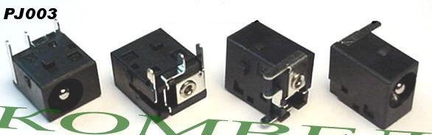
1.65mm
Acer Travelmate: C100, Z9000
Compaq Armada: M700
Compaq Presario M2000 series: M20xx, M21xx, M22xx, M23xx, M24xx, M25xx
HP Pavilion ZE2000 Series: ZE20xx, ZE21xx, ZE22xx, ZE23xx, ZE24xx, ZE25xx
2.0mm
Gateway Tablet: M1200, M1300
Gateway: M275, M305CRV, 400SD4, 400VTX, M405, 450SX4, 450ROG, 450RGH
Gateway Solo: 1150, 5300, 5350, 9100, 9150
2.5mm
HP Pavilion ZT series: ZT1000, ZT1100, ZT1125, ZT1130, ZT1135, ZT1145, ZT1155, ZT1170, ZT1175, ZT1180, ZT1190, ZT1230, ZT1235, ZT1260
HP Omnibook: XT1500
Toshiba Satellite: 1000, 1005, 1200, 3000-S303, 3000-S304, 3000-S307, 3000-S309, 3000-S353, 3000-S403, 3000-S514, 3005-S303, 3005-S303, 3005-S307, 3005-S308, 3005-S403, 3005-S504
IBM: I Series
Averatec: 2100, 2200, 3150, 3200, 3220, 3250, 3300, 5110H, 6200, 7100 Series
Clevo-Sager: 98
Asus: M3000N
Hyperdata: 3000
Versa: E120

PJ004
Sony
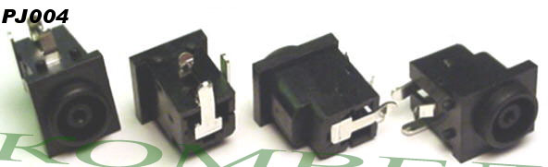
Sony PCG-FX: PCG-FX120, PCG-FX140, PCG-FX150, PCG-FX170, PCG-FX190, PCG-FX200, PCG-FX200K, PCG-FX210, PCG-FX215, PCG-FX220, PCG-FX240, PCG-FX250, PCG-FX270, PCG-FX290, PCG-FX310, PCG-FX318, PCG-FX340, PCG-FX370, PCG-FX390, PCG-FX410, PCG-FX677, PCG-FX776, PCG-FX777, PCG-FX876, PCG-FX877, PCG-FX430, PCG-FXA32, PCG-FXA33, PCG-FXA35, PCG-FXA36, PCG-FXA47, PCG-FXA48, PCG-FXA49, PCG-FXA53, PCG-FXA59, PCG-FXA63
Sony PCG-GR: PCG-GR150, PCG-GR170, PCG-GR250, PCG-GR290, PCG-GR370, PCG-GR390, PCG-GRS150, PCG-GRS170, PCG-GRS175, PCG-GRS300, PCG-GRS700, PCG-GRS750, PCG-GRV550, PCG-GRV570, PCG-GRV670, PCG-GRV680, PCG-GRX500, PCG-GRX501, PCG-GRX510, PCG-GRX520, PCG-GRX530, PCG-GRX550, PCG-GRX560, PCG-GRX570, PCG-GRX580, PCG-GRX590, PCG-GRX606, PCG-GRX650, PCG-GRX670, PCG-GRX690, PCG-GRX700, PCG-GRX707, PCG-GRX770, PCG-GRZ530, PCG-GRZ600, PCG-GRZ610, PCG-GRZ630, PCG-GRZ660
Sony PCG-N: PCG-NVR5K, PCG-NVR7K, PCG-NVR17, PCG-NVR23, PCG-NVR27, PCG-NVR33, PCG-N505, PCG-N170, PCG-N190, PCG-N200, PCG-N290, PCG-NV105, PCG-NV109M, PCG-NV170, PCG-NV170P, PCG-NV190, PCG-NV290
Sony PCG-F: PCG-F150, PCG-F160, PCG-F180, PCG-F190, PCG-F250, PCG-F270, PCG-F280, PCG-F290, PCG-F340, PCG-F350, PCG-F360, PCG-F370, PCG-F390, PCG-F420, PCG-F430, PCG-F450, PCG-F480, PCG-F490, PCG-F505, PCG-F520, PCG-F540, PCG-F560, PCG-F570, PCG-F580, PCG-F590, PCG-F610, PCG-F630, PCG-F640, PCG-F650, PCG-F680, PCG-F690
Sony PCG-FR: PCG-FR130
Sony SR: PCG-SR5k, PCG-SR7k, PCG-SR17, PCG-SR27, PCG-SR33, PCG-SRX77, PCG-SRX87, PCG-SRX99
Sony TR: PCG-TR1, PCG-TR2
Sony VX: PCG-VX88, PCG-VX89
Sony XG: PCG-XG18, PCG-XG19, PCG-XG28, PCG-XG29, PCG-XG38, PCG-XG39, PCG-XG500, PCG-XG700
Panasonic Toughbook: CF01, CF17, CF25, CF27, CF28, CF33, CF34, CF35, CF37, CF45, CF47, CF48, CF61, CF62, CF63, CF71, CF72
Fujitsu Stylistic: LT P-600
Fujitsu Lifebook: I4187, 635T, B Series: B2545, B2562, B2566, B2545, B2562, B2566, C Series: C352, C320, C4235, C6527, C6581, C6631, C7651, P Series: P1120, P2120, S Series: S6000, S6210, S6231, T Series: T3010

PJ005
Toshiba и Fujitsu, Диаметр центрального контакта 2.0 и 2.5мм.
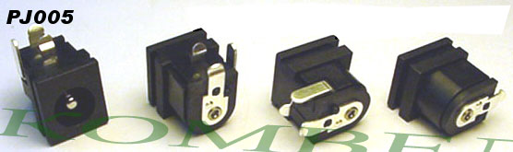
2.5mm
Fujitsu: C2010
3.0mm
Toshiba Libretto: 50 and 70 series
Toshiba Portege: 300, 310 and 320 series, 2000 series, 7000CT, 7010CT, 7020CT, 7140CT, 7200CT
Toshiba Satellite: 300CDS, 305CDS, 310CDs, 315CDS, 320CDS, 320CDT, 325CDS, 330CDS, 330CDT, 335CDS, 335CDT, 1200 SMALL BUSINESS, 1500, 1555, 1555CDS, 1800, 1800-S177, 1800-S202, 1800-S203, 1800-S204, 1800-S205, 1800-S206, 1800-S207, 1800-S253, 1800-S254, 1800-S256, 1800-S274, 1805, 1805-S154, 1805-S177, 1805-S203, 1805-S204, 1805-S207, 1805-S208, 1805-S253, 1805-S254, 1805-S255, 1805-S273, 1805-S274, 1805-S278, 2060, 2060CDS, 2060CDT, 2065, 2065CDS, 2065CDT, 2100, 2100CDS, 2100CDT, 2100CDX, 2105, 2105CDS, 2105CDT, 2115, 2115CDS, 2140, 2140CDT, 2140XCDS, 2180, 2180CDT, 2500, 2500CDS, 2500CDT, 2505, 2505CDS, 2505CDT, 2510, 2510CDS, 2510CDS/4, 2515, 2515CDS, 2515CDS/4, 2515CTS, 2520, 2520CDT, 2530, 2530CDS, 2530CDS/4, 2535, 2535CDS, 2535CDS/4, 2535CDT, 2540, 2540CDS, 2540CDS/4, 2540CDT, 2545, 2545CDS, 2545CDS/4, 2545CDT, 2545XCDT, 2545XCDT/4, 2590, 2590CDS, 2590CDS/4, 2590CDT, 2590XDVD, 2595, 2595CDS, 2595CDS/4, 2595CDT, 2595XDVD, 2600, 2610DVD, 2615, 2615DVD, 2655, 2655XDVD, 2675, 2675DVD, 2695, 2695DVD, 2700, 2710, 2710XDVD, 2715, 2715DVD, 2715XDVD, 2755, 2755DVD, 2755XDVD, 2770, 2770XDVD, 2775, 2775XDVD, 2800, 2800-S201, 2800-S202, 2800-S210, 2805, 2805-S201, 2805-S202, 2805-S301, 2805-S302, 2805-S401, 2805-S402, 2805-S503, 2805-S603, 2900 series, 4000, 4000CDS, 4000CDS/4, 4000CDT, 4000SCDS/4, 4005, 4005CDS, 4005CDS/4, 4005CDT, 4010, 4010CDS, 4010CDS/4, 4010CDT, 4015, 4015CDS, 4015CDS/4, 4015CDT, 4020, 4020CDT, 4020CDT/6, 4025, 4025CDS, 4025CDT, 4025CDT/6, 4030, 4030CDS, 4030CDT, 4030CDT/4, 4035, 4035CDT, 4060, 4060CDT, 4060CDT/4, 4060XCDT, 4070, 4070CDS, 4070CDT, 4080, 4080CDT, 4080XCDT, 4080XCDT/6, 4085, 4085XCDT, 4090, 4090CDS, 4090XCDT, 4090XDVD, 4090XDVD/6, 4100, 4100XCDT, 4100XDVD, 4100XDVD/6, 4260, 4260DVD, 4280, 4280XDVD, 4280ZDVD, 4300, 4300ZDVD, 4320, 4320ZDVD, 4340, 4340ZDVD, 4360, 4360ZDVD, 4600 Series, 5000, 5005, 5005-S504, 5005-S507, 5005-S508, 5005-S607, 5005-S608, 5100, 5105, 5105-S501, 5105-S502, 5105-S607, 5105-S608, 5105-S701, 5105-S702, 5105-S901, 5105-S902, 5200, 5205, 5205-S119, 5205-S502, 5205-S503, 5205-S504, 5205-S505, 5205-S506, 5205-S515, 5205-S703, 5205-S704, 5205-S705, 5205-S5151, 5205-SP505
Toshiba Satelite M30/M35 Board Harness: M30-S309, M30-S3091, M30-S350, M30-S3501, M30-SP309, M30-SP350, M35-S320, M35-S3201, M35-S359, M35-S3591, M35-S3592, M35-SP309, M35-SP350, M35-SP3501
Toshiba Satelite M20 Harness: M20, M20-S257, M20-S258
Pro: Pro 4280ZDVD, Pro 4280XDVD, Pro 4320, Pro 4340, Pro 4360, Pro 440CDT, Pro 440CDX, Pro 445CDX, Pro 460CDT, Pro 460CDX, Pro 465CDX, Pro 470CDT, Pro 480CDT, Pro 490CDT, Pro 490XCDT
Tecra: 500CDT, 500CS, 510CDT, 520CDT, 530CDT, 550CDT, 730XCDT, 750CDT, 750DVD, 780CDM, 780DVD, 8000 (12.1'' Active, Dual Scan, 13.3"' TFT), 8100 (13", 14" Display), 8200, 9000, 9100
Tecra Harness: PE2100, TE2000, TE2100, TE2300

PJ006
Диаметр центрального контакта 2.0 и 2.5мм.
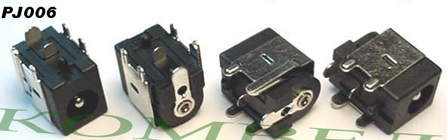
2.0mm
Gateway: M500, M505
2.5mm
Toshiba Satellite: 1105, 1110-S153, 1115-S103, 1115-S104, 1115-S107, 1115-S123
HP Pavilion: N5415, N5425 and others from the N54xx series that use this type shield
IBM: R30, R31, R32

PJ007
Диаметр центрального контакта 2.0 и 2.5мм.
Advent, Arm, Ashton Digital, Fujitsu, Hyperdata, Systemax, Uniwill
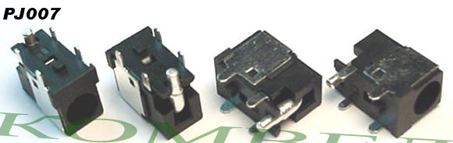
Advent, Arm, Ashton Digital, Hyperdata, Systemax, Uniwill: N34AS1 & N351S1
Fujitsu: L6825, D1840, D1845, D7830
Note: Any of the models listed above may use either center pin sizes, please verify the size you need.

PJ008
Toshiba and Gateway
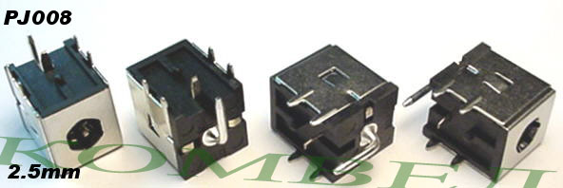
Toshiba Satellite: A35, P35, A60, A65, M20 Series
Gateway: M675 (that uses the standard round ac adapter)

PJ009
Toshiba
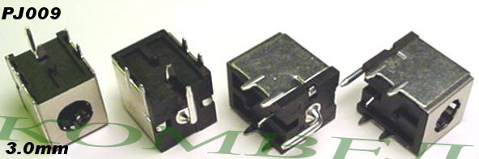
Toshiba Satellite: P10, P15, P20, P25 Series

PJ010
Диаметр центрального контакта 1.4 и 6.4мм.
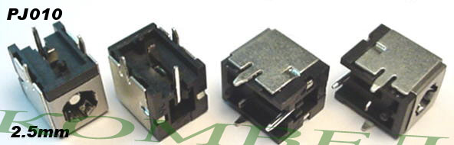

PJ011
Compaq, HP, IBM, Toshiba and Gateway.
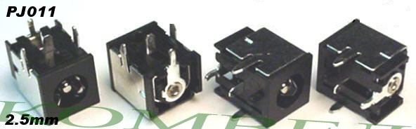
HP ZD Series: ZD7000, ZD7001EA, ZD7001US, ZD7005EA, ZD7005QV, ZD7005US, ZD7009EA, ZD7010ca, ZD7010EA, ZD7010QV, ZD7010US, ZD7012EA, ZD7015EA, ZD7015US, ZD7020EA, ZD7020US, ZD7030EA, ZD7030US, ZD7035EA, ZD7038EA, ZD7040EA, ZD7040US, ZD7045EA, ZD7048CL, ZD7048EA, ZD7049EA, ZD7050, ZD7050EA, ZD7050US, ZD7055EA, ZD7058CL, ZD7060EA, ZD7063EA, ZD7065EA, ZD7066EA, ZD7070EA, ZD7080EA, ZD7101, ZD7101US, ZD7102US, ZD7112EA, ZD7120EA, ZD7128EA, ZD7129EA, ZD7131EA, ZD7139EA, ZD7140US, ZD7141, ZD7141EA, ZD7143EA, ZD7144EA, ZD7145EA, ZD7150EA, ZD7160ca, ZD7160US, ZD7167EA, ZD7168CL, ZD7168EA, ZD7169EA, ZD7170EA, ZD7180US, ZD7188CL, ZD7198CL, ZD7201US, ZD7202US, ZD7228EA, ZD7229EA, ZD7230EA, ZD7230US, ZD7235EA, ZD7236EA, ZD7245EA, ZD7248EA, ZD7249CL, ZD7250EA, ZD7255EA, ZD7256EA, ZD7257EA, ZD7258EA, ZD7259EA, ZD7260EA, ZD7260US, ZD7265EA, ZD7267EA, ZD7269CL, ZD7270EA, ZD7280US, ZD7283EA, ZD7300EA, ZD7310ca, ZD7310US, ZD7320EA, ZD7340EA, ZD7341EA, ZD7342EA, ZD7348EA, ZD7349EA, ZD7350EA, ZD7360US, ZD7373EA, ZD7374EA, ZD7375EA, ZD7376EA, ZD7377EA, ZD7378EA, ZD7379CL, ZD7379EA, ZD7380EA, ZD7380US, ZD7381EA, ZD7382EA, ZD7383EA, ZD7385EA, ZD7389CL, ZD7390EA, ZD7392EA, ZD7395EA, ZD7998US, ZD7999US
HP ZV series: ZV5000, ZV5000t, ZV5000z, ZV5001US, ZV5002, ZV5002US, ZV5003AP, ZV5004AP, ZV5005AP, ZV5010AP, ZV5012AP, ZV5015AP, ZV5021AP, ZV5029AP, ZV5030US, ZV5034US, ZV5037WM, ZV5045EA, ZV5101US, ZV5103, ZV5103AP, ZV5103US, ZV5105US, ZV5120, ZV5120CA, ZV5120US, ZV5160, ZV5160CA, ZV5160US, ZV5200, ZV5200T, ZV5201, ZV5201US, ZV5202, ZV5210, ZV5210ca, ZV5210US, ZV5220, ZV5220US, ZV5240US, ZV5227, ZV5230, ZV5235, ZV5240, ZV5242QV, ZV5247LA, ZV5255US, ZV5257LA, ZV5260US, ZV5267LA, ZV5270US, ZV5277LA, ZV5287LA, ZV5316US, ZV5320, ZV5325, ZV5330, ZV5330, ZV5340, ZV5343, ZV5346, ZV5348, ZV5360, ZV5370, ZV5380, ZV5386, ZV6000
HP ZX series: ZX5000, ZX5002, ZX5040US, ZX5040EA, ZX5041, ZX5060US, ZX5065US, ZX5070US, ZX5078, ZX5180US, ZX5190US, ZX5200, ZX5275US, ZX5280US
HP Business NoteBook: NX9100 series, NX9110
Compaq Presario: R3000, R3000T, R3000Z, R3001, R3001US, R3002, R3003, R3003US, R3004, R3004US, R3005, R3005US, R3020, R3030, R3030US, R3038, R3038CL, R3040, R3050, R3050US, R3055, R3055CA, R3055US, R3056RS, R3060, R3060CA, R3060EA, R3060US, R3065, R3065US, R3070, R3070US, R3120CA, R3120US, R3140, R3140CA, R3140US, R3150, R3158, R3160, R3160US, R3190, R3190EA, R3190US, R3200, R3210, R3220, R3230, R3240, R3265, R3290, R3550US
Compaq Presario: 3000, 3000US, 3005, 3005US, 3008, 3008CL, 3015, 3015CA, 3015US, 3016US, 3017, 3017CL, 3017US, 3019, 3019CL, 3020, 3020US, 3045, 3045US, 3050, 3050US, 3070, 3070US, 3077, 3077WM, 3080, 3080US
*Gateway 4000 Series: M325, 4012GZ, 4024GZ, 4025GZ, 4026GZ, 4028GZ, 4028JP, 4030GZ, 4520GZ, 4525GZ, 4530GH, 4530GZ, 4535GZ, 4536GZ, 4538GZ, 4540GZ, 4541BZ, 4542GP, 4543BZ
*Gateway 7000 Series: M520, 7110GX, 7210GX, 7215GX, 7305GZ, 7320GZ, 7322GZ,7324GZ, 7325GZ, 7326GZ, 7330GH, 7330GZ, 7405GH, 7405GX, 7410GX, 7415GX, 7422GX, 7426GX, 7508GX, 7510GX, MX7118, MX7315, MX7337, MX7337H, MX7340, MX7515, MX7515H, MX7525, S-7200C
IBM Thinkpad: 570E, 600, 600A, 600D, 600E, 600X, A20, A20M, A20P, A21, A21E, A21M, A21P, A22, A22E, A22M, A22P, A30, A30P, A31, A31P, X, X20, X21, X22, X23, X24, X30
Toshiba Satellite: A70, A75, A79, M30X, M35X, L15-S104, 1800, 1900, 1905, 1955
Acer TravelMate: 430, 1500, 1510, 2200
*eMachine: M2100 Series, M2300 series, M6800 Series
Fujitsu Amilo: L1300
Packard Bell: E5, E6
WinBook: 700 series
*Gateway is known to use both 2.0mm and 2.5mm center pin sizes, personal verification must be done in order to get the correct part. The 2.5mm pin size is the most common size used, please see PJ012 for the 2.0mm size.
*eMachines is known to use both 1.65mm and 2.5mm center pin sizes, personal verification must be done in order to get the correct part. The 2.5mm pin size is the most common size used, please see PJ013 for the 1.65mm size.

PJ012
Gateway Диаметр центрального контакта 2.0 мм.
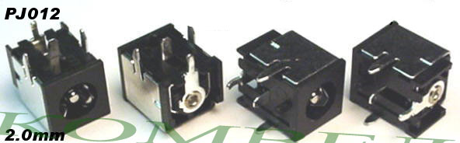
Gateway Solo: 9300 series
Gateway: M520 (note: The M520 is known to also use the 2.5mm center pin size, please verify what you need)

PJ013
Compaq Диаметр центрального контакта 1.65мм.
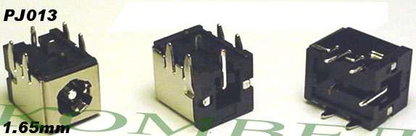
Compaq Presario: 900, 903, 904, 905, 906, 907, 908, 909, 910, 911, 912, 914, 915, 916, 917, 918, 919, 920, 921, 922, 925, 927, 930, 935, 940, 943, 945, 950, 955, 1500, 1505, 1507, 1508, 1510, 1515, 1522, 1523, 1525, 1527
Compaq EVO: N1000C, N1000V, N1005V, N1015V, N1020V
Note: This Jack is for use with AC adapter tips that are 5.5mm in diameter or larger only. Some systems only require 2 pins of the outer Shield, all you need to do is clip off or bend up the outer shield pins you do not need.

PJ014
Compaq и Acer, Диаметр центрального контакта 1.65мм.
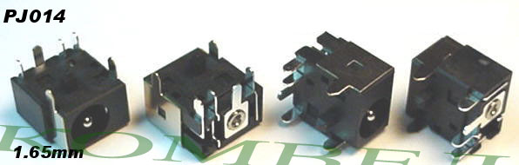
Compaq Presario: X1000 CTO, X1001US, X1002US, X1005EA, X1005LA, X1006EA, X1007EA, X1010AL, X1010CA, X1010EA, X1010US, X1011AL, X1012AL, X1012EA, X1012QV, X1015US, X1016EA, X1018CL, X1020EA, X1020US, X1021AP, X1022AP, X1023AP, X1026AP, X1027AP, X1028AP, X1028CL, X1029AP, X1030AP, X1030US, X1031AP, X1032AP, X1033AP, X1034AP, X1035AP, X1036AP, X1037AP, X1038AP, X1040AP, X1040US, X1041AP, X1042AP, X1043AP, X1044AP, X1045AP, X1046AP, X1047AP, X1048AP, X1049AP, X1050AP, X1050CA, X1050US, X1051AP, X1052AP, X1053AP, X1054AP, X1055AP, X1056AP, X1057AP, X1058AP, X1058CL, X1060AP, X1061AP, X1062AP, X1063AP, X1064AP, X1065AP, X1066AP, X1067AP, X1068AP, X1069AP, X1070AP, X1071AP, X1072AP, X1073AP, X1074AP, X1075AP, X1076AP, X1077AP, X1078AP, X1079AP, X1080AP, X1081AP, X1082AP, X1083AP, X1084AP, X1085AP, X1086AP, X1087AP, X1088AP, X1089AP, X1090AP, X1091AP, X1092AP, X1093AP, X1094AP, X1095AP, X1096AP, X1097AP, X1098AP, X1099AP, X1105EA, X1110EA, X1115EA, X1140EA, X1155EA, X1200, X1201AP, X1201US, X1202AP, X1203AP, X1204AP, X1205AP, X1206AP, X1207AP, X1208AP, X1209AP, X1210AP, X1210CA, X1210US, X1211AP, X1212AP, X1213AP, X1214AP, X1215AP, X1216AP, X1217AP, X1218AP, X1219AP, X1220AP, X1220EA, X1220US, X1221AP, X1222AP, X1223AP, X1224AP, X1225AP, X1227AP, X1228AP, X1229AP, X1230AP, X1230US, X1231AP, X1232AP, X1233AP, X1234AP, X1236AP, X1237AP, X1238AP, X1239AP, X1240AP, X1241AP, X1242AP, X1300 CTO, X1301AP, X1301US, X1302AP, X1303AP, X1304AP, X1305AP, X1306AP, X1307AP, X1308AP, X1309AP, X1310AP, X1311AP, X1312AP, X1313AP, X1314AP, X1315AP, X1316AP, X1317AP, X1318AP, X1319AP, X1320AP, X1321AP, X1322AP, X1324AP, X1325AP, X1326AP, X1327AP, X1328AP, X1329AP, X1330AP, X1360CA, X1360US, X1370US, X1390, X1390US, X1397, X1400 CTO, X1400AD, X1401AP, X1401US, X1402AP, X1402US, X1403AP, X1404AP, X1405AP, X1406AP, X1407AP, X1408AP, X1409AP, X1410AP, X1411AP, X1412AP, X1413AP, X1414AP, X1415AP, X1416AP, X1417AP, X1418AP, X1419AP, X1420AP, X1421AP, X1422AP, X1423AP, X1424AP, X1425AP, X1426AP, X1427AP, X1428AP, X1429AP, X1430AP, X1431AP, X1432AP, X1433AP, X1434AP, X1435AP, X1436AP, X1437AP, X1438AP, X1439AP, X1440AP, X1441AP, X1442AP, X1443AP, X1444AP, X1445AP, X1460CA, X1460US, X1480, X1480US, X1500 CTO, X1560CA
Business Notebook: NX7000
HP Pavilion: zt3xxx series, zt3001US, zt3001US, zt3007LA, zt3010AP, zt3010EA, zt3010US, zt3010US, zt3011AP, zt3012AP, zt3012EA, zt3013AP, zt3014AP, zt3015AP, zt3015EA, zt3016AP, zt3017AP, zt3017EA, zt3017LA, zt3017WM, zt3017wm, zt3018AP, zt3019AP, zt3019EA, zt3020, zt3020AP, zt3020EA, zt3020US, zt3021AP, zt3022AP, zt3022EA, zt3023AP, zt3024AP, zt3024EA, zt3025AP, zt3026AP, zt3027AP, zt3028AP, zt3029AP, zt3030AP, zt3030EA, zt3031AP, zt3032AP, zt3033AP, zt3034AP, zt3035AP, zt3036AP, zt3037AP, zt3038AP, zt3039AP, zt3040AP, zt3041AP, zt3042AP, zt3043AP, zt3044AP, zt3045AP, zt3046AP, zt3047AP, zt3048AP, zt3049AP, zt3050AP, zt3050EA, zt3051AP, zt3057LA, zt3068CL, zt3068cl, zt3100, series, zt3101EA, zt3101US, zt3101US, zt3105EA, zt3106EA, zt3110EA, zt3111EA, zt3113EA, zt3114EA, zt3115EA, zt3116EA, zt3120EA, zt3130EA, zt3131EA, zt3140US, zt3140us, zt3170US, zt3170us, zt3200, zt3201AP, zt3201us, zt3201us, zt3202AP, zt3203AP, zt3204AP, zt3205AP, zt3206AP, zt3207AP, zt3208AP, zt3209AP, zt3210AP, zt3210EA, zt3211AP, zt3211EA, zt3212AP, zt3212EA, zt3213AP, zt3214AP, zt3214EA, zt3215AP, zt3215EA, zt3216AP, zt3217AP, zt3218AP, zt3219AP, zt3220AP, zt3220EA, zt3221AP, zt3222AP, zt3223AP, zt3224AP, zt3225AP, zt3228AP, zt3229AP, zt3230AP, zt3231AP, zt3232AP, zt3232EA, zt3235AP, zt3236AP, zt3237AP, zt3239EA, zt3240EA, zt3241EA, zt3242EA, zt3250, zt3250us, zt3250us, zt3260EA, zt3280us, zt3280us, zt3300, zt3301AP, zt3301us, zt3302AP, zt3302us, zt3302us, zt3303AP, zt3304AP, zt3305AP, zt3306AP, zt3307AP, zt3308AP, zt3309AP, zt3310AP, zt3310EA, zt3311AP, zt3312AP, zt3312EA, zt3313AP, zt3314AP, zt3314EA, zt3315AP, zt3315EA, zt3316AP, zt3316EA, zt3317AP, zt3318AP, zt3319AP, zt3320AP, zt3320EA, zt3321AP, zt3322AP, zt3323AP, zt3324AP, zt3325AP, zt3326AP, zt3327AP, zt3328AP, zt3329AP, zt3329EA, zt3330AP, zt3330EA, zt3331AP, zt3332AP, zt3333AP, zt3334AP, zt3335AP, zt3336AP, zt3337AP, zt3338AP, zt3339AP, zt3340AP, zt3340EA, zt3340us, zt3340us, zt3341AP, zt3342AP, zt3343AP, zt3344AP, zt3345AP, zt3346AP, zt3347AP, zt3348AP, zt3349AP, zt3349cl, zt3349cl, zt3350AP, zt3350EA, zt3350us, zt3350us, zt3351AP, zt3351EA, zt3352AP, zt3353AP, zt3354AP, zt3355AP, zt3355us, zt3355us, zt3356AP, zt3357AP, zt3358AP, zt3359AP, zt3360AP, zt3368EA, zt3370EA, zt3377LA, zt3379LA, zt3380LA, zt3380us, zt3380us, zt3380XX, zt3400 CTO, zt3418EA, zt3420EA, zt3440EA, zt3447EA, zt3449EA, zt3450EA, zt3451EA, zt3459EA, zt3460EA, zt3461EA, zt3462EA, zt3463EA, zt3464EA, zt3465EA
Acer TravelMate: C300, 622, 800, TM800, 800LCi, 800XC, 800XCi, 802, 802LCi, 803, 803LCi, 804, 804LMi, 2300 series, 2400 series, 4000 series, 5000 series
Acer Aspire: 1200 Series, 1410, 1500, 1520, 1610, 1620, 1641WLMI, 1642WLMI, 1660, 1670, 1680, 2001WLCi, 2303WLCI, 2413, 3000, 3002LCI, 3003WLCI, 3210, 3500, 3610, 4000 series, 4150, 4400, 5000 Series, 5003WLMi, 7100 Series, 8100 Series

PJ015
Compaq, HP, Gateway, Toshiba и другие
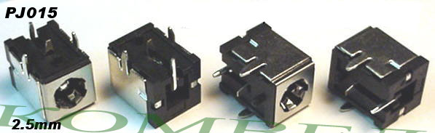
HP ZD Series: ZD7000, ZD7001EA, ZD7001US, ZD7005EA, ZD7005QV, ZD7005US, ZD7009EA, ZD7010ca, ZD7010EA, ZD7010QV, ZD7010US, ZD7012EA, ZD7015EA, ZD7015US, ZD7020EA, ZD7020US, ZD7030EA, ZD7030US, ZD7035EA, ZD7038EA, ZD7040EA, ZD7040US, ZD7045EA, ZD7048CL, ZD7048EA, ZD7049EA, ZD7050, ZD7050EA, ZD7050US, ZD7055EA, ZD7058CL, ZD7060EA, ZD7063EA, ZD7065EA, ZD7066EA, ZD7070EA, ZD7080EA, ZD7101, ZD7101US, ZD7102US, ZD7112EA, ZD7120EA, ZD7128EA, ZD7129EA, ZD7131EA, ZD7139EA, ZD7140US, ZD7141, ZD7141EA, ZD7143EA, ZD7144EA, ZD7145EA, ZD7150EA, ZD7160ca, ZD7160US, ZD7167EA, ZD7168CL, ZD7168EA, ZD7169EA, ZD7170EA, ZD7180US, ZD7188CL, ZD7198CL, ZD7201US, ZD7202US, ZD7228EA, ZD7229EA, ZD7230EA, ZD7230US, ZD7235EA, ZD7236EA, ZD7245EA, ZD7248EA, ZD7249CL, ZD7250EA, ZD7255EA, ZD7256EA, ZD7257EA, ZD7258EA, ZD7259EA, ZD7260EA, ZD7260US, ZD7265EA, ZD7267EA, ZD7269CL, ZD7270EA, ZD7280US, ZD7283EA, ZD7300EA, ZD7310ca, ZD7310US, ZD7320EA, ZD7340EA, ZD7341EA, ZD7342EA, ZD7348EA, ZD7349EA, ZD7350EA, ZD7360US, ZD7373EA, ZD7374EA, ZD7375EA, ZD7376EA, ZD7377EA, ZD7378EA, ZD7379CL, ZD7379EA, ZD7380EA, ZD7380US, ZD7381EA, ZD7382EA, ZD7383EA, ZD7385EA, ZD7389CL, ZD7390EA, ZD7392EA, ZD7395EA, ZD7998US, ZD7999US, ZD8000, ZD8002, ZD8003, ZD8004
HP ZV series: ZV5000, ZV5000t, ZV5000z, ZV5001US, ZV5002, ZV5002US, ZV5003AP, ZV5004AP, ZV5005AP, ZV5010AP, ZV5012AP, ZV5015AP, ZV5021AP, ZV5029AP, ZV5030US, ZV5034US, ZV5037WM, ZV5045EA, ZV5101US, ZV5103, ZV5103AP, ZV5103US, ZV5105US, ZV5120, ZV5120CA, ZV5120US, ZV5160, ZV5160CA, ZV5160US, ZV5200, ZV5200T, ZV5201, ZV5201US, ZV5202, ZV5210, ZV5210ca, ZV5210US, ZV5220, ZV5220US, ZV5240US, ZV5227, ZV5230, ZV5235, ZV5240, ZV5242QV, ZV5247LA, ZV5255US, ZV5257LA, ZV5260US, ZV5267LA, ZV5270US, ZV5277LA, ZV5287LA, ZV5316US, ZV5320, ZV5325, ZV5330, ZV5330, ZV5340, ZV5343, ZV5346, ZV5348, ZV5360, ZV5370, ZV5380, ZV5386, ZV6000
HP ZX series: ZX5000, ZX5002, ZX5040US, ZX5040EA, ZX5041, ZX5060US, ZX5065US, ZX5070US, ZX5078, ZX5180US, ZX5190US, ZX5200, ZX5275US, ZX5280US
Compaq Presario: R3000, R3000T, R3000Z, R3001, R3001US, R3002, R3003, R3003US, R3004, R3004US, R3005, R3005US, R3020, R3030, R3030US, R3038, R3038CL, R3040, R3050, R3050US, R3055, R3055CA, R3055US, R3056RS, R3060, R3060CA, R3060EA, R3060US, R3065, R3065US, R3070, R3070US, R3120CA, R3120US, R3140, R3140CA, R3140US, R3150, R3158, R3160, R3160US, R3190, R3190EA, R3190US, R3200, R3210, R3220, R3230, R3240, R3265, R3290, R3550US
Compaq Presario: 3000, 3000US, 3005, 3005US, 3008, 3008CL, 3015, 3015CA, 3015US, 3016US, 3017, 3017CL, 3017US, 3019, 3019CL, 3020, 3020US, 3045, 3045US, 3050, 3050US, 3070, 3070US, 3077, 3077WM, 3080, 3080US
IBM Thinkpad: 570E, 600, 600A, 600D, 600E, 600X, A20, A20M, A20P, A21, A21E, A21M, A21P, A22, A22E, A22M, A22P, A30, A30P, A31, A31P, X, X20, X21, X22, X23, X24, X30
Toshiba Satellite: A70, A75, A79, M30X, M35X, L15-S104, 1800, 1900, 1905, 1955

PJ016
Acer, Asus, Dell, Packard Bell и Toshiba
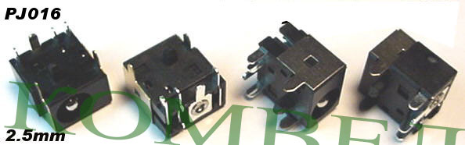
Dell Inspiron: 1000, 1200, 1300, 2000, 2200, B120, B130
Toshiba Satellite: 1130 Series, 1135 Series, 2430 Series, 2435 Series
Acer Aspire: 1350
Acer Ferrari: 3000, 3000LMI, 3200, 3400, 4000
Acer Travlemate: 2700, 4500
Asus: A2500H Series
Packard Bell Easynote: C3 Series, C3205, C3223, C3227, C3255, C3265, C3300, C3302
Chembook: CQ12-15

PJ017
Compaq и HP
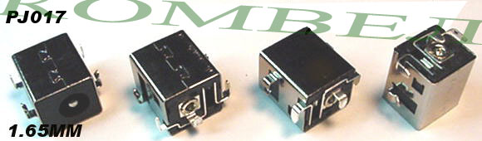
Compaq Presario V4000 Series: V4000 CTO, V4000, V4000T CTO, V4000XX, V4001AP, V4002AP, V4002XX, V4003AP, V4003XX, V4004AP, V4004XX, V4005CL, V4005XX, V4015US, V4020US, V4025US, V4035CA, V4035EA, V4035US, V4040EA, V4050EA, V4055EA, V4058EA, V4060EA, V4075EA, V4100 CTO, V4101AP, V4102AP, V4103AP, V4104AP, V4105AP, V4106AP, V4107AP, V4108AP, V4109AP, V4110AP, V4110EA, V4111AP, V4112AP, V4113AP, V4114AP, V4115AP, V4116AP, V4117AP, V4118AP, V4119AP, V4120EA, V4120TU, V4120US, V4121TU, V4122TU, V4125CL, V4130EA, V4133EA, V4135US, V4144EA, V4145EA, V4146EA, V4147EA, V4160EA, V4200 CTO, V4201TU, V4201XX, V4202EA, V4202TU, V4202XX, V4203EA, V4203TU, V4203XX, V4204TU, V4205EA, V4205TU, V4206TU, V4207TU, V4208TU, V4209TU, V4210TU, V4211TU, V4212TU, V4213TU, V4214TU, V4215EA, v4215TU, V4216TU, V4217EA, V4217TU, V4218TU, V4219TU, V4220EA, V4220NR, V4220TU, V4221TU, V4222TU, V4223TU, V4224TU, V4225TU, V4226TU, V4227TU, V4228TU, V4229TU, V4230TU, V4231TU, V4232TU, V4233TU, V4240US, V4245US, V4260EA, V4263EA, V4265EA, V4274EA, V4275EA, V4276EA, V4278EA, V4285EA, V4305EA, V4308EA, V4310NR, V4320EA, V4322EA, V4325CA, V4325US, V4332EA, V4332US, V4333EA, V4335EA, V4336EA, V4338EA, V4347EA, V4354EA, V4376EA, V4377EA, V4382EA, V4387EA, V4400 CTO, V4401TU, V4402TU, V4402XX, V4403TU, V4404TU, V4405TU, V4406TU, V4407TU, V4408TU, V4435NR, V4440US, V4450EA
HP Pavilion DV4000 Series: DV4000 CTO, DV4000LA, DV4000XX, DV4001AP, DV4001EA, DV4001XX, DV4002AP, DV4003AP, DV4004AP, DV4004XX, DV4005AP, DV4005US, DV4005XX, DV4006AP, DV4006XX, DV4007AP, DV4007XX, DV4008AP, DV4009AP, DV4010AP, DV4011AP, DV4012AP, DV4013AP, DV4014AP, DV4014EA, DV4015AP, DV4015CL, DV4015EA, DV4016AP, DV4016EA, DV4017AP, DV4017EA, DV4018AP, DV4018CL, DV4018EA, DV4019AP, DV4019EA, DV4020AP, DV4020EA, DV4021AP, DV4021EA, DV4022AP, DV4022EA, DV4023AP, DV4023EA, DV4024AP, DV4024EA, DV4025AP, DV4025EA, DV4026AP, DV4027EA, DV4029EA, DV4030CA, DV4030EA, DV4030US, DV4031EA, DV4040CA, DV4040EA, DV4040US, DV4043EA, DV4045EA, DV4046EA, DV4049EA, DV4050EA, DV4051EA, DV4052EA, DV4054EA, DV4056EA, DV4057EA, DV4060EA, DV4070EA, DV4073EA, DV4075EA, DV4078EA, DV4080EA, DV4085EA, DV4086EA, DV4100 CTO, DV4100, DV4101AP, DV4102AP, DV4102EA, DV4103AP, DV4103EA, DV4104AP, DV4105AP, DV4106AP, DV4107AP, DV4108AP, DV4108EA, DV4109AP, DV4109EA, DV4110AP, DV4110EA, DV4111AP, DV4112AP, DV4113AP, DV4113EA, DV4114AP, DV4115AP, DV4115EA, DV4116AP, DV4117AP, DV4118AP, DV4119AP, DV4120AP, DV4121AP, DV4122AP, DV4122EA, DV4123AP, DV4124AP, DV4124EA, DV4125AP, DV4125EA, DV4125US, DV4126AP, DV4126EA, DV4127AP, DV4128AP, DV4128EA, DV4129AP, DV4129EA, DV4129US, DV4130AP, DV4130ea, DV4130US, DV4131EA, DV4134EA, DV4135EA, DV4135LA, DV4136EA, DV4137EA, DV4138EA, DV4139EA, DV4140EA, DV4141EA, DV4142EA, DV4143EA, DV4144EA, DV4145EA, DV4146EA, DV4148EA, DV4149EA, DV4150CA, DV4150EA, DV4150US, DV4151EA, DV4152EA, DV4153EA, DV4154EA, DV4155CL, DV4155EA, DV4155US, DV4156EA, DV4157EA, DV4158EA, DV4159EA, DV4160EA, DV4161EA, DV4162EA, DV4163EA, DV4164EA, DV4165CL, DV4165EA, DV4170CA, DV4170US, DV4174EA, DV4176EA, DV4178EA, DV4182EA, DV4199EA, DV4200 CTO, DV4200, DV4200EA, DV4201EA, DV4201TU, DV4201TX, DV4201XX, DV4202EA, DV4202TU, DV4202TX, DV4202XX, DV4203EA, DV4203TU, DV4203TX, DV4203XX, DV4204EA, DV4204TU, DV4204TX, DV4205EA, DV4205TU, DV4205TX, DV4206EA, DV4206TU, DV4206TX, DV4207EA, DV4207TU, DV4207TX, DV4208EA, DV4208TX, DV4209TX, DV4210TX, DV4211TX, DV4212TX, DV4213EA, DV4213TX, DV4214TX, DV4215TX, DV4216EA, DV4216TX, DV4217CL, DV4217TX, DV4218EA, DV4218TX, DV4219TX, DV4220TX, DV4221TX, DV4222TX, DV4223CL, DV4223EA, DV4223TX, DV4224EA, DV4224TX, DV4225EA, DV4225NR, DV4225TX, DV4226EA, DV4226TX, DV4227EA, DV4230US, DV4231EA, DV4232EA, DV4234EA, DV4235EA, DV4236EA, DV4241EA, DV4243EA, DV4245EA, DV4246EA, DV4250CA, DV4250EA, DV4250US, DV4251EA, DV4253EA, DV4253US, DV4254EA, DV4257US, DV4261EA, DV4264EA, DV4266EA, DV4268EA, DV4269EA, DV4269US, DV4270CA, DV4270EA, DV4270US, DV4271EA, DV4272EA, DV4272US, DV4273EA, DV4275EA, DV4275NR, DV4276EA, DV4277EA, DV4280EA, DV4282EA, DV4283EA, DV4284EA, DV4285EA, DV4287EA, DV4288EA, DV4289EA, DV4290EA, DV4291EA, DV4294EA, DV4295EA, DV4296EA, DV4302EA, DV4304EA, DV4305EA, DV4305US, DV4306EA, DV4307CA, DV4307CL, DV4308WM, DV4309EA, DV4310US, DV4312EA, DV4315EA, DV4318EA, DV4320US, DV4321EA, DV4322EA, DV4324EA, DV4325EA, DV4326EA, DV4327EA, DV4330CA, DV4330US, DV4334EA, DV4335EA, DV4335NR, DV4336EA, DV4337EA, DV4339EA, DV4340CA, DV4340US, DV4342EA, DV4344EA, DV4346EA, DV4348EA, DV4350EA, DV4351EA, DV4353EA, DV4354EA, DV4356EA, DV4357EA, DV4358EA, DV4360EA, DV4363EA, DV4364EA, DV4365EA, DV4367EA, DV4368EA, DV4376EA, DV4378EA, DV4379EA, DV4381EA, DV4383EA, DV4384EA, DV4385EA, DV4386EA, DV4388EA, DV4391EA, DV4392EA, DV4394EA, DV4395EA, DV4396EA, DV4398EA, DV4400 CTO, DV4401TU, DV4401XX, DV4402TU, DV4405NR, DV4410CA, DV4410US, DV4419US, DV4420CA, DV4420US, DV4430EA, DV4435EA, DV4440EA, DV4445EA, DV4450EA

PJ018
Gateway M, NX, S, 3000 и 6000 серии
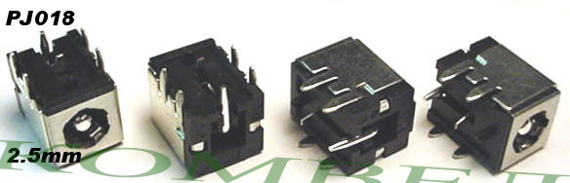
Gateway: M210, M250GS, M250G, M250ES, M250E, M250A, M250B, M360, M360A, M360B, M360C, M460, M460A, M460B, M465QS, M465G, M465E, M520, NX100X, NX200S, NX200X, NX250X, NX500S, NX500S w/S-Video, NX500X, NX500X w/S-Video, NX510S, NX550X, NX550XL, NX560X, NX560XL, S-7200N, S-7500N, S-7510N, S-7700N, S-7710N
Gateway 3000 Series: 3018GZ, 3040GZ, 3520GZ, 3522GZ, 3525GB, 3545GZ, 3550GH, 3550GZ, 3610GZ, MX3042, MX3044, MX3044h, MX3210, MX3212, MX3215, MX3225, MX3228, MX3228h, MX3230, MX3231, MX3311b, MX3410, MX3410h, MX3412, MX3412h, MX3414, MX3416, MX3417, MX3422, MX3558, MX3558h, MX3560, MX3560h, MX3562, MX3563, MX3563h, MX3610, MX3701, MX3702
Gateway 6000 Series: 6010GZ, 6018GH, 6018GZ, 6020GZ, 6021GZ, 6022GZ, 6023GP, 6510GZ, 6518GZ, 6520GZ, 6525GP, 6531GZ, MX6025, MX6025h, MX6027, MX6027h, MX6028, MX6030, MX6121, MX6123, MX6124, MX6124h, MX6128, MX6131, MX6135, MX6214, MX6216, MX6420, MX6421, MX6422, MX6423, MX6424, MX6424h, MX6425, MX6426, MX6427, MX6428, MX6429, MX6430, MX6431, MX6433, MX6436, MX6437, MX6438, MX6439, MX6440, MX6440h, MX6441, MX6442, MX6444, MX6444h, MX6445, MX6446, MX6447, MX6448, MX6450, MX6452, MX6453, MX6454, MX6455, MX6625, MX6627, MX6627h, MX6629, MX6629h, MX6631, MX6633, MX6633h, MX6640b, MX6641 MX6641h, MX6650, MX6650h, MX6708, MX6708h, MX6710, MX6750, MX6750h, MX6912, MX6919, MX6920, MX6920h, MX6927, MX6930, MX6930h, MX6931, MX6951, MX6951h, MX6955, MX6956, MX6957, MX6958, MX6959, MX6960, MX6961, MX6961h

PJ019
Compaq и HP
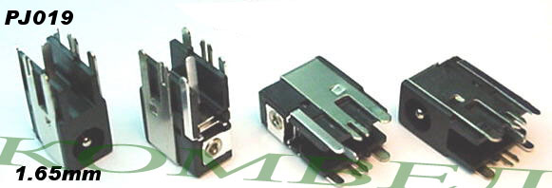
Compaq Presario V2000 series: V20xx, V21xx, V22xx, V23xx, V24xx, V25xx, V26xx
HP Pavilion DV1000 Series: DV10xx, DV11xx, DV12xx, DV13xx, DV14xx, DV15xx, DV16xx, DV17xx
HP Compaq Business Notebook: NX4800, NX4820
The listings below are for the Jacks for the Main System Board only, not the Power Connector Board. Please see PJ003-1.65mm here for the Power Connector Board Jack that the AC adapter plugs into.
Compaq Presario M2000 series: M20xx, M21xx, M22xx, M23xx, M24xx, M25xx
HP Pavilion ZE2000 Series: ZE20xx, ZE21xx, ZE22xx, ZE23xx, ZE24xx, ZE25xx

PJ020
HP-Compaq
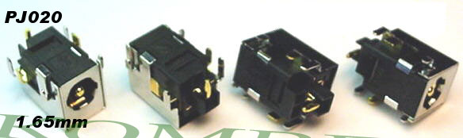
HP-Compaq: NX6110, NC6110, NX6120, NC6120, NX8200 Series, NC8200 Series

PJ021
Gateway
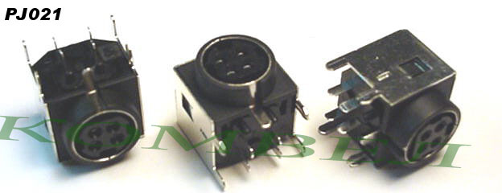
Gateway: M350 and M675 that uses the DIN style AC adapter plug.

PJ022
Gateway, Micron и Samsung
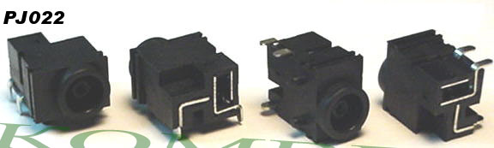
Gateway: 200ARC
Samsung: X10, V20, V25, VM6000, VM7000
Micron: Metrobook VL Plus and Transport GX series

PJ023
Samsung
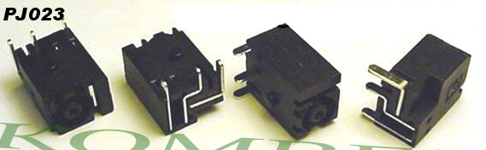
Samsung: A10

PJ024
Samsung
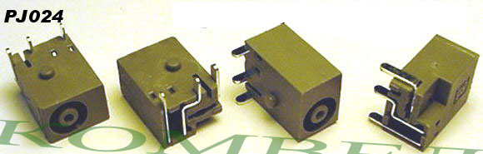
Samsung: P10, Taurus
VPR-Matrix: 120-180b5

PJ025
Samsung
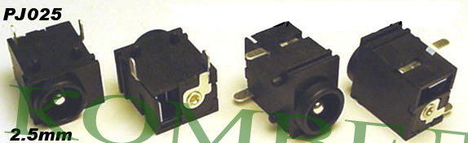
Samsung: V25, V30

PJ026
Gateway и Samsung
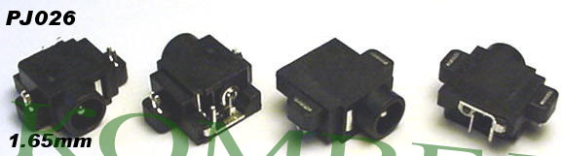
Gateway: 200STM
Samsung: Q series

PJ027
HP
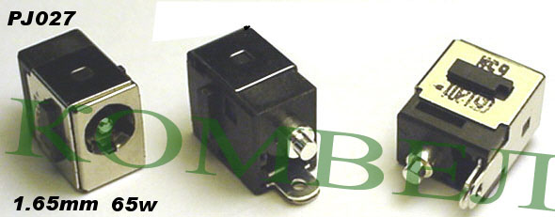
Compaq Presario V5000 Series: V5000 CTO, V5000T CTO, V5002EA, V5004EA, V5005US, V5006EA, V5009EA, V5015CA, V5015US, V5025EA, V5026EA, V5030EA, V5031EA, V5032EA, V5033EA, V5054EA, V5059EA, V5079EA, V5088XX, V5094EA, V5099EA, V5099XX, V5100 CTO, V5100AU, V5100TU, V5101AU, V5101TU, V5101US, V5102AU, V5102EU, V5102NR, V5102TU, V5103AU, V5103TU, V5104AU, V5104EU, V5104TU, V5105CA, V5105EU, V5105TU, V5105US, V5106EU, V5106TU, V5107EU, V5107TU, V5108CU, V5108EU, V5108TU, V5109TU, V5110EU, V5110TU, V5111EU, V5111TU, V5115CA, V5115EU, V5115US, V5116EU, V5119US, V5120EU, V5120NR, V5122EU, V5125EU, V5126EU, V5128EA, V5132EA, V5150EA, V5155EA, V5160EA, V5160US, V5162EA, V5189XX, V5199XX, V5200 CTO, V5201CA, V5201TU, V5201US, V5202TU, V5203TU, V5204NR, V5204TU, V5204US, V5205NR, V5205TU, V5206OM, V5206TU, V5207NR, V5207TU, V5208CA, V5208TU, V5209TU, V5209US, V5210CA, V5210TU, V5210US, V5211TU, V5212TU, V5213TU, V5214EA, V5214TU, V5215EA, V5215LA, V5215TU, V5216EA, V5216TU, V5217TU, V5218LA, V5218TU, V5219TU, V5220EA, V5220TU, V5221EA, V5221TU, V5222EA, V5222TU, V5223TU, V5224TU, V5225TU, V5226TU, V5227TU, V5228TU, V5229TU, V5230TU, V5231TU, V5232EA, V5232TU, V5233EA, V5233TU, V5234EA, V5234TU, V5235EA, V5235TU, V5236EA, V5236EU, V5236TU, V5237TU, V5238TU, V5239TU, V5240TU, V5241TU, V5242TU, V5243TU, V5244TU, V5245EU, V5245TU, V5246TU, V5247TU, V5248TU, V5249TU, V5250TU, V5251TU, V5252TU, V5253TU, V5254TU, V5255TU, V5256TU, V5257TU, V5258TU, V5259TU, V5260TU, V5261TU, V5299XX, V5300 CTO, V5303NR, V5304US, V5305WM, V5306US, V5307US, V5308CA, V5310US, V5315WM
Compaq Presario C300 Series: C300 CTO, C300EA, C300EU, C301NR, C301TU, C302NR, C302TU, C303NR, C303TU, C304NR, C304TU, C305LA, C305TU, C306TU, C306US, C307NR, C307TU, C308LA, C308TU, C309TU, C310EA, C310EU, C310TU, C311TU, C312TU, C313TU, C315LA, C318LA, C350EA, C350EU, C351EA, C352EA, C353EA, C399XX
Compaq Presario C500 Series: C500, C500EA, C500EU, C500T, C501NR, C501TU, C502CA, C502EA, C502EU, C502TU, C502US, C503TU, C503WM, C504EA, C504EU, C504TU, C504US, C505TU, C506CA, C506TU, C507TU, C507US, C508US, C509NR, C518LA, C540EA, C542EA, C550ED, C550EF, C550EL, C550EM, C551NR, C551TU, C552CA, C552TU, C552US, C553TU, C554EM, C554TU, C554US, C555EA, C555EL, C555EM, C555ES, C555EU, C555NR, C555TU, C556CA, C556EM, C556TU, C557CL, C557TU, C558TU, C559CL, C559EF, C559EM, C559TU, C560TU, C560US, C561TU, C562TU, C563NR, C563TU, C564TU, C564US, C565TU, C566TU, C567TU, C568LA, C570EA, C571NR, C571TU, C572TU, C573TU, C574TU, C575TU, C576TU, C577TU, C578TU, C579TU, C580TU, C581TU, C581WM, C582TU
HP Pavilion DV5000 Series: DV5000 CTO, DV5000ea, DV5000t CTO, DV5001xx, DV5002ea, DV5003cl, DV5003ea, DV5005ea, DV5006ea, DV5007ea, DV5008ea, DV5009ea, DV5010ea, DV5011ea, DV5012ea, DV5016ea, DV5017cl, DV5017ea, DV5018ea, DV5020ca, DV5020us, DV5021ea, DV5022ea, DV5023ea, DV5024ea, DV5026ea, DV5027ea, DV5029us, DV5030us, DV5031ea, DV5033ea, DV5034ea, DV5035ea, DV5035nr, DV5036ea, DV5037ea, DV5040us, DV5041ea, DV5046ea, DV5047ea, DV5050ea, DV5051ea, DV5052ea, DV5053ea, DV5054ea, DV5055ea, DV5056ea, DV5057ea, DV5058ea, DV5059ea, DV5061ea, DV5062ea, DV5063ea, DV5074ea, DV5075ea, DV5077ea, DV5078ea, DV5084ea, DV5088xx, DV5091ea, DV5092ea, DV5093ea, DV5094ea, DV5095ea, DV5096ea, DV5097ea, DV5098ea, DV5099ea, DV5099xx
Pavilion DV8000 Series: DV8000 CTO, DV8000T CTO, DV8002EA, DV8005EA, DV8010EA, DV8013CL, DV8013xx, DV8025EA, DV8026EA, DV8027EA, DV8028EA, DV8029EA, DV8030EA, DV8035EA, DV8040CA, DV8040US, DV8040xx, DV8045EA, DV8050EA, DV8051EA, DV8075EA, DV8088US, DV8099xx
Note: This is the Jack only and does not include the harness. You will need to reuse your harness.

PJ028
Acer
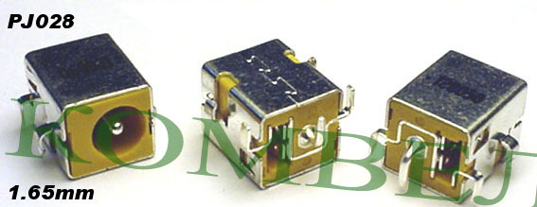
Acer: TM370, C110

PJ029
HP OmniBook
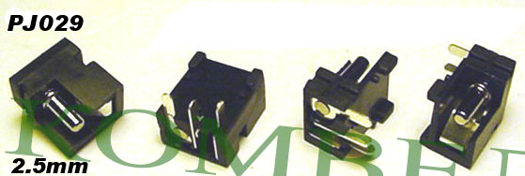
HP OmniBook: OmniBook 900

PJ030
Dell
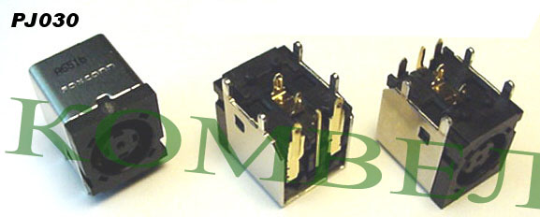
Dell Inspiron: 500M, 600M, 700M, E1505, 1150, 5150, 5160, 6000, 8500, 8600, 9100, 9200, 9300, 9400
Dell Latitude: 100L, D400, D410, D500, D505, D510, D520, D600, D610, D800, D810
Dell Precision Workstation: M20, M60

PJ031
Dell
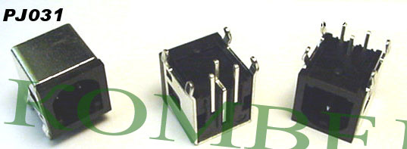
Dell Latitude: C-Series, CP, CPi, CPiA, CPiD, CPiR, CPm, CPt, CPtC, CPtS, CPtV, CPx, CPxH, CPxJ, CS, CSR, CSX, C400, C500, C510, C540, C600, C610, C640, C800, C805, C810, C840, C-Dock, C-Port, V700, V710, V740, Xpi 133ST, Xpi 75, Xpi CD, Xpi P100SD, XPi P133
Dell Inspiron: 1100, 2500, 2600, 2650, 3650, 3700, 3800, 4000, 4100, 4150, 5000, 5000E, 5100, 7500, 8000, 8100, 8200
Dell Precision Workstation: M40, M50

PJ032
HP/Compaq
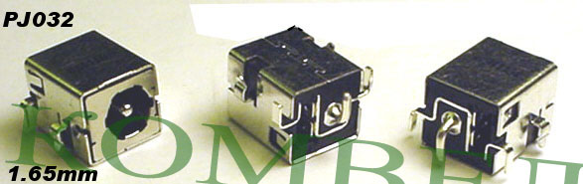
HP/Compaq Business Notebook: NX5000 series
Compaq Presario V1000 series: V1000 CTO, V1001AD, V1001AP, V1002AD, V1002AP, V1003AD, V1003AP, V1004, V1004AD, V1004AP, V1005AD, V1005AP, V1006AD, V1006AP, V1007AD, V1007AP, V1008AD, V1008AP, V1009AD, V1009AP, V1010AP, V1011AP, V1012AP, V1013AP, V1014AP, V1015AP, V1016AP, V1017AP, V1018AP, V1019AP, V1020AP, V1021AP, V1022AP, V1023AP, V1024AP, V1025AP, V1026AP, V1027AP, V1028AP, V1029AP, V1030AP, V1031AP, V1032AP, V1033AP, V1034AP, V1035AP, V1036AP, V1037AP, V1038AP, V1039AP, V1040AP, V1041AP, V1042AP, V1043xx, V1044AP, V1045AP, V1046AP, V1047AP, V1048AP, V1049AP, V1050AP, V1051AP, V1052AP, V1053AP, V1054AP, V1055AP, V1056AP, V1057AP, V1058AP, V1059AP, V1060AP, V1061AP, V1062AP, V1065AP, V1066AP, V1067AP, V1068AP, V1069AP, V1070AP, V1071AP, V1072AP, V1073AP, V1074AP, V1075AP, V1100 CTO, V1101AP, V1102AP, V1103AP, V1104AP, V1105AP, V1106AP, V1107AP, V1108AP, V1109AP, V1110AP, V1111AP, V1112AP, V1113AP, V1114AP, V1115AP, V1116AP, V1117AP, V1118AP, V1119AP, V1120AP, V1121AP, V1122AP, V1123AP, V1124AP, V1125AP, V1126AP, V1127AP, V1128AP, V1129AP, V1130AP, V1131AP, V1132AP, V1133AP, V1134AP

PJ033
Fujitsu Siemens
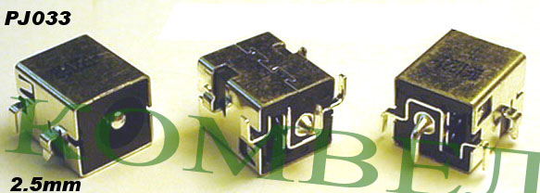
Fujitsu Amilo: M1405, M7405, Pro V2040

PJ034
Acer
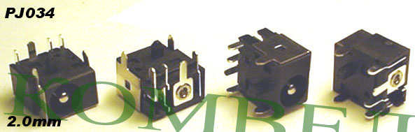
Acer: Compatible models coming soon.

PJ035
HP, Compaq
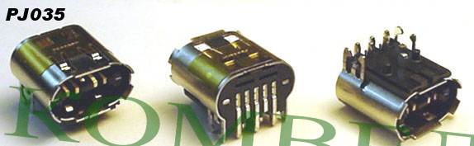
HP ZV6000 Series: zv6000 CTO, zv6000, zv6001XX, zv6002XX, zv6003XX, zv6004EA, zv6004XX, zv6005US, zv6006EA, zv6007US, zv6008CL, zv6009EA, zv6009US, zv6010EA, zv6010US, zv6011EA, zv6013EA, zv6015US, zv6017EA, zv6020EA, zv6024EA, zv6025EA, zv6026EA, zv6027EA, zv6028EA, zv6029EA, zv6061EA, zv6062EA, zv6064EA, zv6065EA, zv6066EA, zv6067EA, zv6068EA, zv6069EA, zv6090EA, zv6100 CTO, zv6100, zv6107WM, zv6114EA, zv6115EA, zv6116EA, zv6117EA, zv6118EA, zv6120EA, zv6123CL, zv6125CL, zv6126EA, zv6127EA, zv6128EA, zv6129EA, zv6130EA, zv6130US, zv6131EA, zv6131US, zv6147EA, zv6148EA, zv6149EA, zv6150EA, zv6151EA, zv6152EA, zv6153EA, zv6156EA, zv6158EA, zv6159EA, zv6170CA, zv6170US, zv6174EA, zv6179EA, zv6180EA, zv6181EA, zv6195EA, zv6196EA, zv6201CL, zv6201EA, zv6203CL, zv6209US, zv6211EA, zv6212EA, zv6213EA, zv6214EA, zv6215EA, zv6216EA, zv6217EA, zv6218EA, zv6220EA, zv6223CL, zv6230CA, zv6233NR, zv6242EA, zv6243EA, zv6244EA, zv6245EA, zv6246EA, zv6247EA, zv6248EA, zv6249EA, zv6250EA, zv6251EA, zv6252EA, zv6253EA, zv6254EA, zv6255EA, zv6270CA, zv6270US, zv6273EA, zv6274EA, zv6275EA, zv6276EA, zv6278EA, zv6279EA, zv6295EA, zv6296EA, zv6302US
HP ZD8000 Series: zd8000 CTO, zd8001AP, zd8001XX, zd8002AP, zd8002XX, zd8003AP, zd8003XX, zd8004AP, zd8004XX, zd8005AP, zd8007EA, zd8008EA, zd8009EA, zd8010EA, zd8010XX, zd8011XX, zd8015EA, zd8017EA, zd8019EA, zd8020EA, zd8030EA, zd8043EA, zd8044EA, zd8045EA, zd8047EA, zd8048EA, zd8050EA, zd8050LA, zd8050XX, zd8051EA, zd8052EA, zd8053EA, zd8054EA, zd8055US, zd8060CA, zd8060US, zd8070EA, zd8072EA, zd8075EA, zd8076EA, zd8077EA, zd8078EA, zd8079EA, zd8080EA, zd8080us, zd8100 CTO, zd8105CA, zd8105EA, zd8110EA, zd8110US, zd8112EA, zd8115EA, zd8115US, zd8120CL, zd8120EA, zd8122EA, zd8123EA, zd8124EA, zd8125CL, zd8125EA, zd8126EA, zd8127EA, zd8129EA, zd8130EA, zd8135EA, zd8139EA, zd8147EA, zd8148EA, zd8150EA, zd8151EA, zd8155EA, zd8156EA, zd8157EA, zd8158EA, zd8159EA, zd8160EA, zd8162EA, zd8179EA, zd8180EA, zd8181EA, zd8182EA, zd8183EA, zd8184EA, zd8185EA, zd82xxus, zd8200 CTO, zd8201AP, zd8202AP, zd8203AP, zd8204AP, zd8205TU, zd8205US, zd8210CA, zd8214EA, zd8215US, zd8217EA, zd8218EA, zd8219EA, zd8220us, zd8223EA, zd8224EA, zd8225CA, zd8225EA, zd8226EA, zd8227EA, zd8228EA, zd8229EA, zd8230EA, zd8230us, zd8231EA, zd8234EA, zd8235EA, zd8237EA, zd8238EA, zd8239EA, zd8245EA, zd8250LA, zd8251EA, zd8252EA, zd8253EA, zd8254EA, zd8255EA, zd8256EA, zd8270EA, zd8280EA, zd8289EA, zd8290EA, zd8291EA, zd8301EA, zd8302EA, zd8303EA, zd8304EA, zd8305EA, zd8306EA, zd8307EA, zd8308EA, zd8315CA, zd8315EA, zd8316EA, zd8317EA, zd8318EA, zd8319EA, zd8320EA, zd8323EA, zd8325EA, zd8333CL, zd8342EA, zd8350LA, zd8367EA, zd8368EA, zd8369EA, zd8388EA, zd8389EA, zd8390EA, zd8398EA, zd8399EA, zd8399xx, zd8401EA, zd8410EA, zd8430CA, zd8460EA, zd8480EA, zd8490EA
HP/Compaq Business Notebook: NX9600 Series
Compaq Presario X6000 Series: X6000 CTO, X6001XX, X6002XX, X6003XX, X6050CA, X6050US, X6070US, X6100 CTO, X6105CL, X6110US, X6125CL
Compaq Presario R4000 Series: R4000 CTO, R4000, R4001XX, R4002XX, R4003EA, R4003XX, R4005EA, R4006EA, R4009EA, R4010CA, R4010US, R4012EA, R4012US, R4015EA, R4016EA, R4017EA, R4024EA, R4025CA, R4025EA, R4025US, R4026EA, R4028EA, R4029EA, R4030EA, R4031EA, R4035CA, R4060EA, R4065EA, R4075EA, R4207EA, R4221EA, R4100 CTO, R4114EA, R4115EA, R4115US, R4125CA, R4125EA, R4125US, R4126EA, R4127EA, R4127US, R4130EA, R4145EA, R4146EA, R4150EA, R4155EA, R4157EA, R4205EA, R4206EA, R4208EA, R4209EA, R4218EA, R4219EA, R4220EA, R4222EA, R4225CA

PJ036
Sony
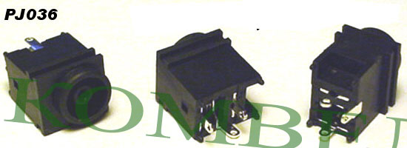
Sony VGN: VGN-FS620 (PCG-7A2L), VGN-FS620P, VGN-FS625B, VGN-FS635B, VGN-FS640, VGN-FS640W, VGN-FS645P, VGN-FS660, VGN-FS660P, VGN-FS675P, VGN-FS680
Sony Z505: PCG-Z505ES, PCG-Z505ESK, PCG-Z505FA, PCG-Z505FAT, PCG-Z505GA, PCG-Z505GAT, PCG-Z505GE, PCG-Z505HE, PCG-Z505HS, PCG-Z505HSK, PCG-Z505LE, PCG-Z505LEK, PCG-Z505LS (PCG-531A), PCG-Z505JEK, PCG-Z505JSK, PCG-Z505JE (PCG-5211), PCG-Z505JS (PCG-5201), PCG-Z505LE, PCG-Z505LEK, PCG-Z505R, PCG-Z505RX, PCG-Z505S, PCG-Z505SX

PJ037
Gateway
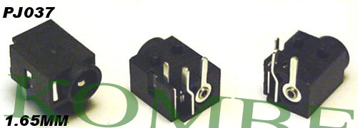
Gateway Solo: 3400, 3450

PJ038
Acer
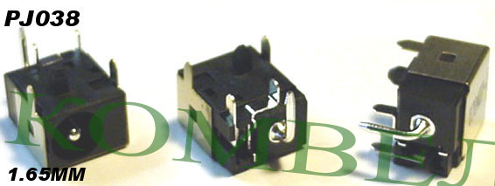
Acer TravelMate: 290e, 2350, 4200
Acer Aspire: 3100, 3690, 4720Z, 5070, 5100, 5610Z, 9500

PJ039
GPS System
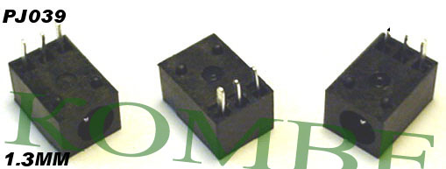
Roadmate GPS System: 300

PJ040
Sony
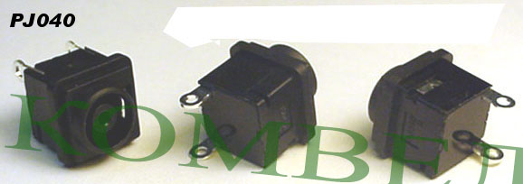
Sony PCG-K Series: PCG-K12, PCG-K12P, PCG-K13, PCG-K13F, PCG-K14, PCG-K15, PCG-K15F (PCG-9P6L), PCG-K17, PCG-9P6L, PCG-K23, PCG-K25, PCG-K27, VGN-K31, VGN-K31B, PCG-K33, PCG-K33P, PCG-K33F, PCG-K33Q, PCG-K34FP, PCG-K35, PCG-K35F, PCG-K37 (PCG-9S1L), PCG-K45, PCG-K43F, PCG-K43Q, PCG-K44FP, PCG-K45F, PCG-K47, PCG-K64, PCG-K66P, VGN-K71B, PCG-K86P, PCG-K86SP, PCG-K315B, PCG-K315M, PCG-K315S, PCG-K315Z, PCG-K415B, PCG-K415S
Sony VGN-A Series: VGN-A21, VGN-A51PS1, VGN-A51PS2, VGN-A51S1, VGN-A51S2, VGN-A61B, VGN-A71PS, VGN-A71S, VGN-A100, VGN-A130 (PCG-8Q8L), VGN-A130B, VGN-A130P (PCG-8Q9L), VGN-A140, VGN-A140P, VGN-A150, VGN-A160, VGN-A170 (PCG-8Q1L), VGN-A170B, VGN-A170P (PCG-8Q4L), VGN-A190 (PCG-8Q5L), VGN-A215M, VGN-A215Z, VGN-A217M, VGN-A230, VGN-A230B, VGN-A230P (PCG-8R9L), VGN-A240, VGN-A240B, VGN-A240P, VGN-A250, VGN-A260 (PCG-8R7L), VGN-A270, VGN-A270B, VGN-A270P (PCG-8R1L), VGN-A290, VGN-A290F (PCG-8R4L), VGN-A295HP, VGN-A297XP, VGN-A600, VGN-A600B, VGN-A600P (PCG-8S3L), VGN-A690 (PCG-8S4L), VGN-A790 (PCG-8T2L)
Sony VGN-AR Series: VGN-AR170 (PCG-8V1L)
Sony PCG-GRT Series: PCG-GRT100 (PCG-8M2R), PCG-GRT100K, PCG-GRT100P (PCG-8M1R), PCG-GRT150 (PCG-8M3L), PCG-GRT160 (PCG-8M4L), PCG-GRT170 (PCG-8M2L), PCG-GRT230 (PCG-8N2L), PCG-GRT240, PCG-GRT250, PCG-GRT250K, PCG-GRT260, PCG-GRT270, PCG-GRT270G, PCG-GRT270K, PCG-GRT270P (PCG-8N1L), PCG-GRT280ZG (PCG-8N3L), PCG-GRT350, PCG-GRT390
Sony VGN-BX Series: VGN-BX540B
Note: This is for the DC Jack only, you will need to reuse your exiting harness cables.

PJ040.1
Sony
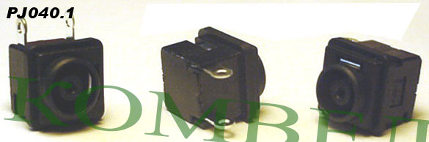
Sony PCG-FR Series: PCG-FR860, PCG-FR862, PCG-FR870, PCG-FR872
Sony PCG-FRV Series: PCG-FRV23, PCG-FRV25, PCG-FRV26, PCG-FRV27, PCG-FRV28, PCG-FRV31, PCG-FRV33, PCG-FRV34, PCG-FRV35, PCG-FRV37
Sony VGN-FJ Series: VGN-FJ150W, VGN-FJ170B, VGN-FJ170PB, VGN-FJ180PB, VGN-FJ250, VGN-FJ250P, VGN-FJ270, VGN-FJ270P, VGN-FJ290, VGN-FJ290P, VGN-FJ370
Sony VGN-CR Series: VGN-CR240E
Note: This is for the DC Jack only, you will need to reuse your exiting harness cables.

PJ041
Samsung
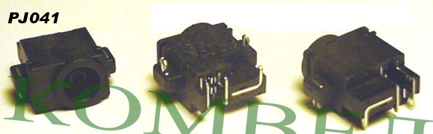
Samsung: P40, X60

PJ042
Acer
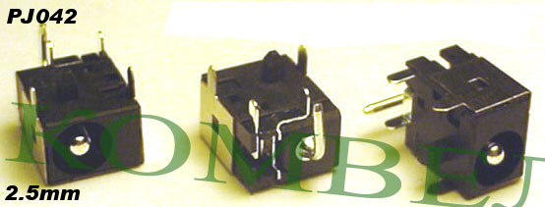
Acer: Compatible models coming soon!

PJ043
Sony, Compaq
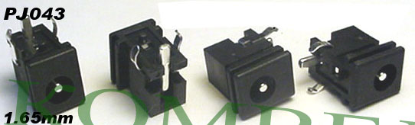
Sony: Play Station 2
Compaq: Some Docking Stations

PJ044
Fujitsu Siemens
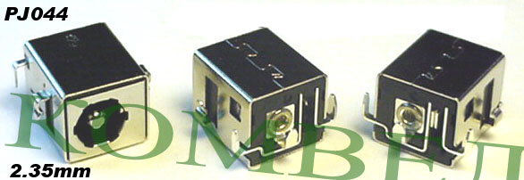
Fujitsu Siemens: Amilo 1650

PJ045
Compa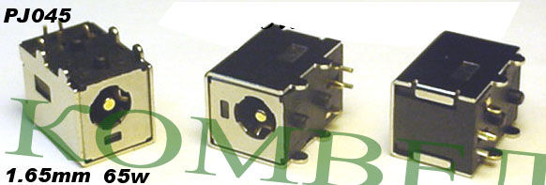q, HP

Compaq Persario: V6000 Series, for 65 watt AC adapters
HP Pavilion: DV6000 and DV9000 Series, for 65 watt AC adapters

PJ046
Fujitsu Siemens, Sony
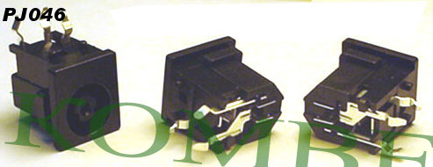
Fujitsu Lifebook: S2000, S2010, S2020, S5582, S6110, S6120
Sony: PCG-731

PJ047
Acer
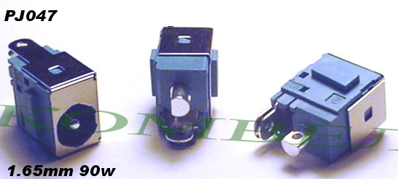
Aspire: 5672WLMi

PJ048
Compaq, HP
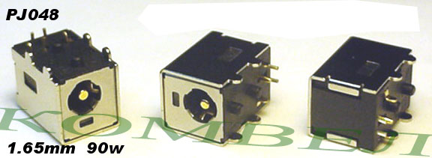
Compaq Persario: V6000 Series, for 65 watt AC adapters
HP Pavilion: DV6000 and DV9000 Series, for 90 watt AC adapters

